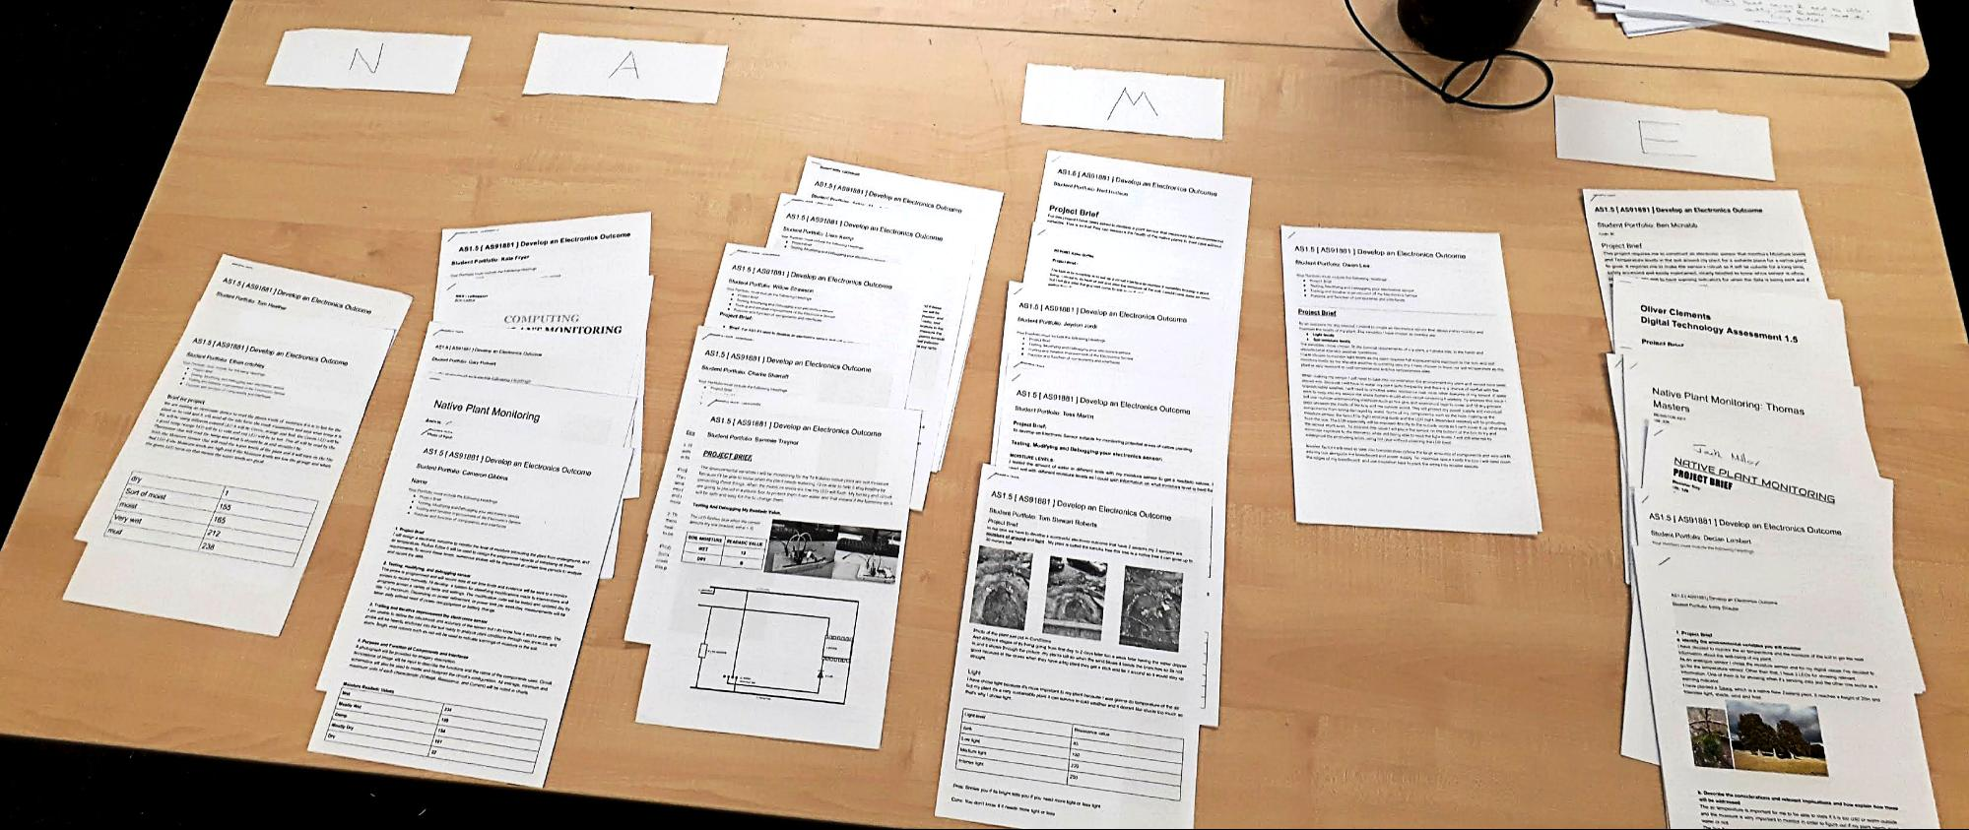

Annotations on a marking schedule can be used to justify teacher judgement OR to record teacher observations and conversations with students

